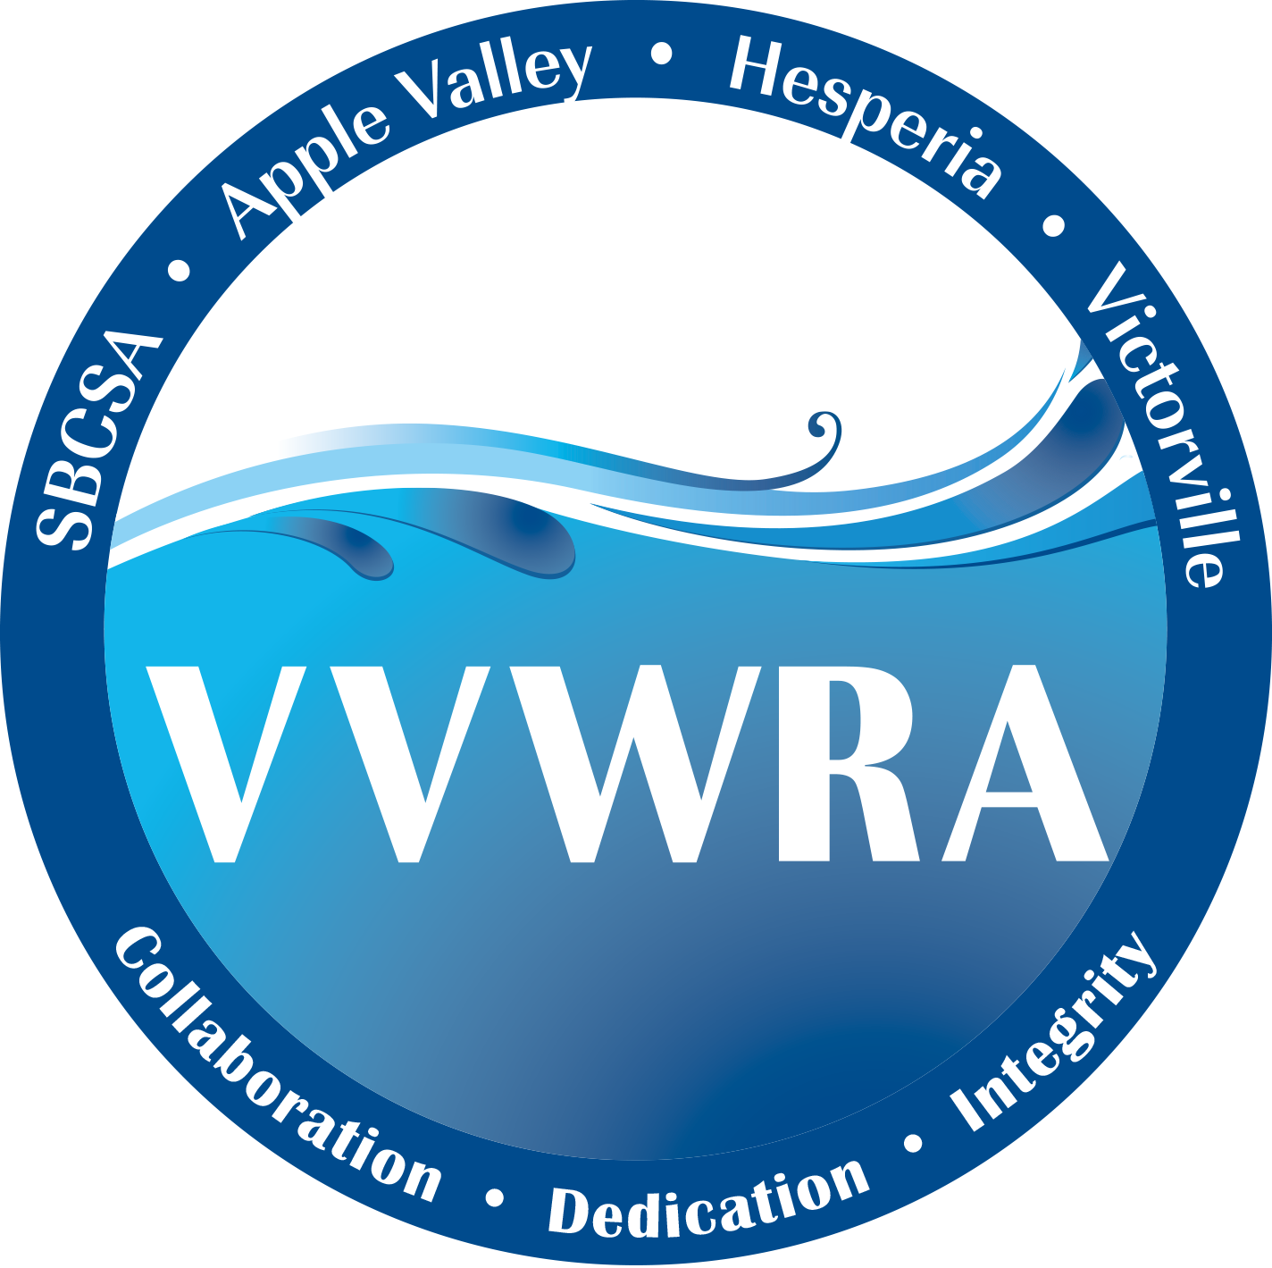

VICTOR VALLEY WASTEWATER RECLAMATION AUTHORITY

****NOTICE OF CANCELLATION OF REGULAR MEETING***
**OF JUNE 27, 2024 **

NOTICE IS HEREBY GIVEN that the Regular Meeting of the Commission of the Victor Valley Wastewater Reclamation Authority (“VVWRA”) scheduled for Thursday, June 27, 2024 has been canceled.

The next regularly scheduled meeting of the VVWRA Commission is for Thursday, July 18, 2024.

SAID MEETING will be conducted at Victorville City Hall – Conference Room “D”, 14343 Civic Drive, Victorville, CA 92392.

A copy of the Agenda will be duly posted at Victorville City Hall and may also be reviewed at VVWRA 20111 Shay Road, Victorville CA 92394.

