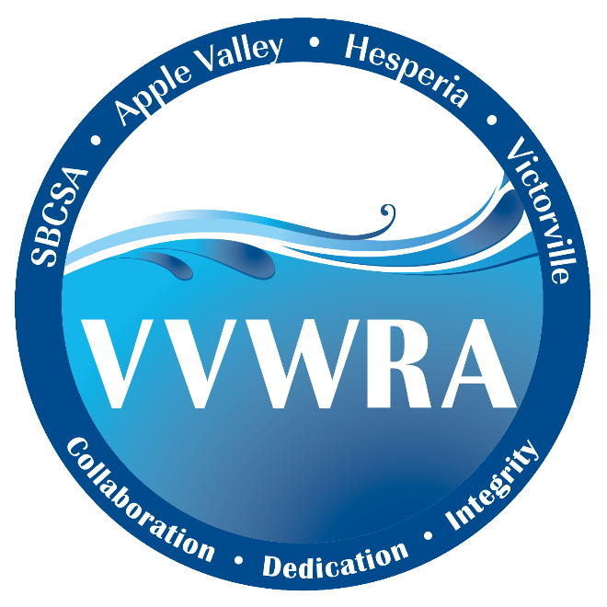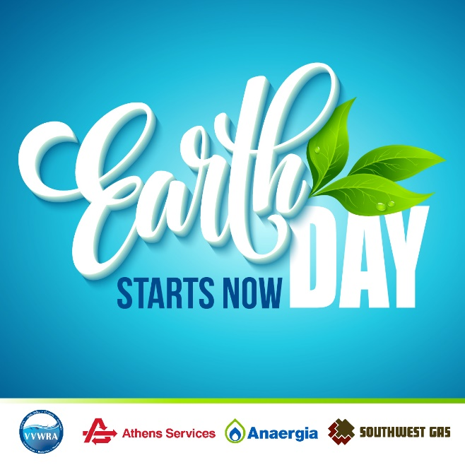

PRESS RELEASE
March 28, 2024

Earth Day Event at VVWRA on April 20th

Go Behind the Scenes of Public Health and Environmental Protection at Earth Day Event
Celebration Includes Free Food, Kids Zone, and Facility Tours

Victorville, CA— Come enjoy an Earth Day celebration! Victor Valley Wastewater Reclamation Authority (VVWRA), Athens Services, Anaergia, and Southwest Gas invite the community to explore how their operations promote environmental stewardship and sustainability. Earth Day Starts Now will be held April 20, from 10 a.m. to 2 p.m. at VVWRA’s Main Plant located at 20111 Shay Rd, Victorville, CA.

Attendees are encouraged to tour VVWRA’s water recycling facilities. Plus, learn about the cutting-edge technology that is turning waste into energy through a partnership between VVWRA, Anaergia and Southwest Gas. Visit Athens Services nearby site, which is one of Southern California’s most advanced composting facilities and learn how Athens Services turns organic waste into compost and mulch.

In addition to visiting informational booths and free lunch, a Kids Zone will educate and create a space for family fun. Radio station Y-102 and Air personality Coleen Quinn will also be there.

“The work we do to protect public health and provide renewable resources often goes unnoticed,” said Darron Poulsen, General Manager of VVWRA. “Earth Day marks an important opportunity for the community to see how we recycle everything from wastewater to green waste., all while having a great time with their family and friends.”

VVWRA has provided wastewater treatment, water recycling, renewable green energy, and nutrient-rich soil amendment services to Victor Valley residents and businesses for more than 40 years.

Working collaboratively with Anaergia, VVWRA maximizes biosolids to reduce greenhouse gas emissions and offer green energy solutions. Nearby, Athens Services processes many types of organic materials and provides compost and mulch.

###

About Victor Valley Wastewater Reclamation Authority
Founded in 1978, VVWRA serves a 279 square mile area that includes Apple Valley, Hesperia, Victorville, Spring Valley Lake, and Oro Grande. VVWRA treats about 12 million gallons of wastewater per day. Wastewater that comes to the VVWRA plant goes through an extensive cleaning and disinfection process before being returned to the Mojave River as recycled water through direct discharge to the river or through percolation ponds located on VVWRA property. Solid waste is treated in large anaerobic digesters, where the resulting methane gas is collected and scrubbed by VVWRA private partner Anaergia, Inc., who develops the gas into renewable natural gas (RNG). The finished RNG is injected into a Southwest Gas pipeline.

Contact:
David Wylie,
VVWRA
Dwylie@vvwra.com
760-523-1781
VVWRACA.gov

