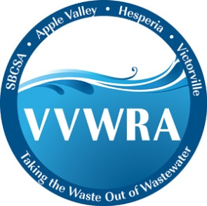***NEWS***

***From the Victor Valley***

***Wastewater Reclamation Authority***

***VVWRA Ranks in Top 30***

***On Green Power Partnership list***

**FOR IMMEDIATE RELEASE** CONTACT:

October 26, 2015 David Wylie 760.523-1781

**Victorville**—The Victor Valley Wastewater Reclamation Authority (VVWRA) is ranked 27th nationally for on-site generation and consumption of green power by the EPA’s Green Power Partnership, according to figures released this morning. The Green Power Partnership’s list of on-site green power producers includes some of the nation’s largest companies like Walmart, Coca Cola and Apple. “We are honored that the EPA has recognized VVWRA for the renewable energy we are generating through our Waste to Energy program”, said VVWRA General Manager Logan Olds.

The Green Power Partnership ranking shows that VVWRA generates 7,446,000 kwh per year which accounts for about 74 percent of the plants total power demand. VVWRA generates green electricity by capturing the naturally occurring methane or bio-gas from the wastewater and using that bio gas to fire a pair of large 800 kwh 2G generators. “Our goal in the near future is to increase the amount of green power we generate to the point where our plant is virtually energy neutral”, said Olds.

The Green Power Partnership is a voluntary program that encourages organizations to use green power as a way to reduce the environmental impacts associated with conventional electricity use.

Reference: <http://www3.epa.gov/greenpower/toplists/top30onsite.htm>

--End--