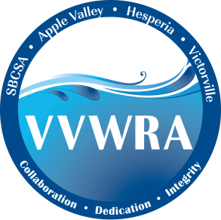

***NEWS***

*From the Victor Valley*

*Wastewater Reclamation Authority*

***VVWRA Adopts New Mission Statement***

**FOR IMMEDIATE RELEASE** CONTACT:

April 16th, 2020 David Wylie 760.246-8638

The VVWRA Board of Commissioners has unanimously approved a new mission statement, a set of core values and an update to the agencies logo. “The mission statement is designed to establish a guide that drives the decision making and goal setting process for our organization", said VVWRA General Manager Darron Poulsen. The new mission statement reads:

***"VVWRA is committed to protecting public health and the environment in the Victor Valley by providing effective and fiscally responsible wastewater collection, treatment and recycling."***

VVWRA’s protects public health and the environment by safely treating nearly 11 million gallons of wastewater per day. The new mission statement reflects VVWRA’s renewed commitment to our member agencies and our core business operations.

To build on the mission statement, VVWRA has also established a set of three core values;

* Collaboration
* Dedication
* Integrity

Under Poulsen’s direction, VVWRA is taking a more collaborative and service oriented approach to its mission. “The core values show our renewed commitment to working together for the best interest of our member agencies, our staff and the community. And we are doing that in an open, fair and honest manner”, said Poulsen. “Everything we do is filtered through these core values”.

To communicate the change in approach, the core values have been added to VVWRA’s logo as a subtle, but purposeful message about the agencies mission.

VVWRA is a Joint Powers Authority that provides wastewater services for the Town of Apple Valley, the City of Hesperia, the City of Victorville, and portions of San Bernardino County, including Spring Valley Lake and Oro Grande.