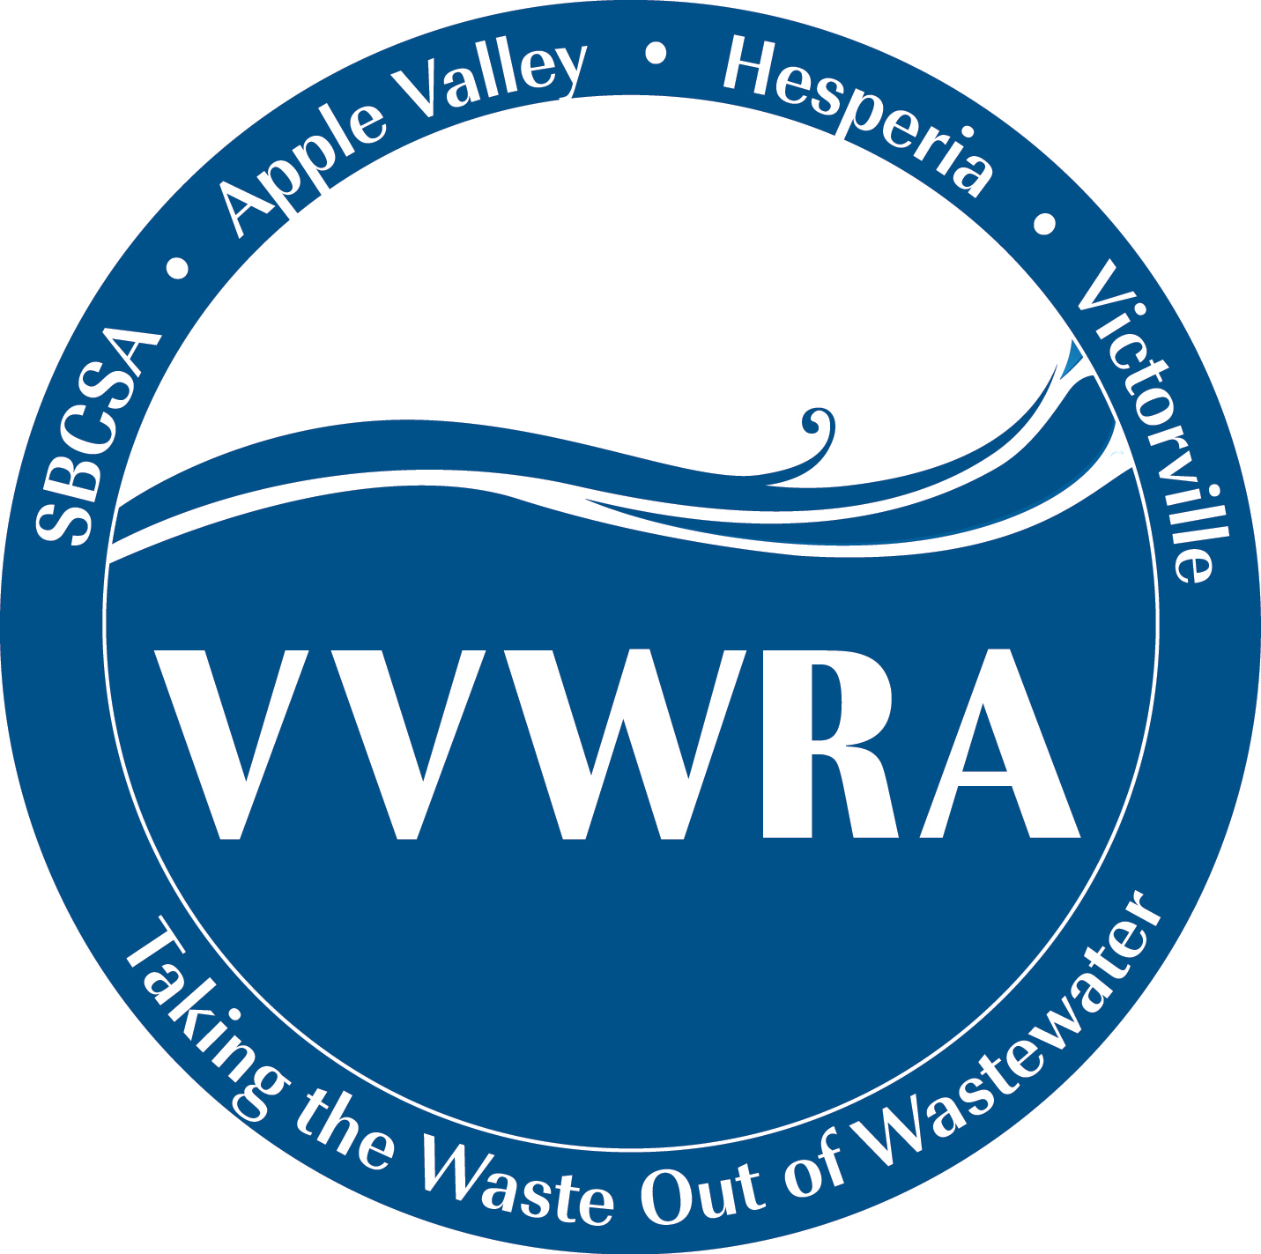

VICTOR VALLEY WASTEWATER
RECLAMATION AUTHORITY
20111 Shay Road
Victorville, CA 92394
(760) 246-8638

WORKSHOP CANCELLATION

NOTICE

NOTICE IS HEREBY GIVEN that the Victor Valley Wastewater Reclamation Authority Board of Commissioners Workshop scheduled for Tuesday, December 4, 2018 at Victorville City Hall – Conference Room “D”, 14343 Civic Drive, Victorville, CA 92392 has been canceled.

